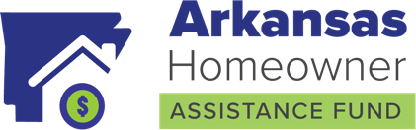
We encourage partners to follow our Facebook page and like and share our posts! Below are suggested posts you can use on your channels.

OPTION 1:
Behind on your mortgage? You may be eligible for the Arkansas Homeowner Assistance Fund (HAF). Arkansas HAF is a free federally funded program helping Arkansas residents who are behind on their mortgages, electricity, gas and/or internet payments. This payment is a grant, and you will not be required to repay.

Take advantage of this opportunity today and find out if you’re eligible. Visit arkansashaf.com or call 888.698.0964 to learn more.

OPTION 2:
The Arkansas Homeowner Assistance Fund (HAF) is a free federally funded program helping Arkansas residents who are at least two months behind on their mortgages, electricity, gas and/or internet payments. You might qualify for assistance if:
✓ You own and occupy a primary residence in Arkansas
✓ You have experienced a financial hardship
✓ Your income falls withing the low-to-moderate income eligibility ranges.
Learn more, visit arkansashaf.com or call 888.698.0964

OPTION 3:
Apply today for the Arkansas Homeowner Assistance Fund (HAF). This program is free, and it helps low-to-moderate income households catch up on their delinquent mortgages and certain other homeowner expenses.
Have questions? Learn more at arkansashaf.com or call 888.698.0964.

OPTION 4:
Behind on your mortgage? You may qualify for the free Arkansas Homeowner Assistance Fund (HAF). If you are eligible, you can use these funds for:
✓ Mortgage delinquency
✓ Utility and/or internet services
✓ And some premiums, fees, taxes and other costs that are included in your mortgage (escrowed)
Check and see if you qualify. Go to arkansashaf.com or call 888.698.0964

